# Read ‘READ ME – save csv.docx’ first

# Purpose

* Quickly saves worksheest into UTDF csv files
* Does not require premade UTDF tabs
* Faster than ‘save csv – working.py”

# Requirements

1. **MUST** have “#” and Synchro node number in a specific location

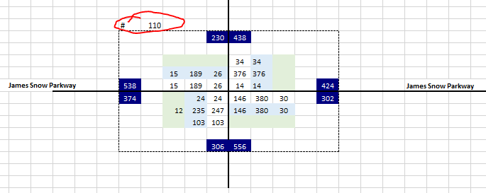

*\*\* this idea was taken from Eric’s volume spreadsheet with macros (spreadsheet provided in main folder)*

1. with Spyder (or other GUI / text editor) you need to manually change the list variable “**search_list**” located approximately line 37 of the script.

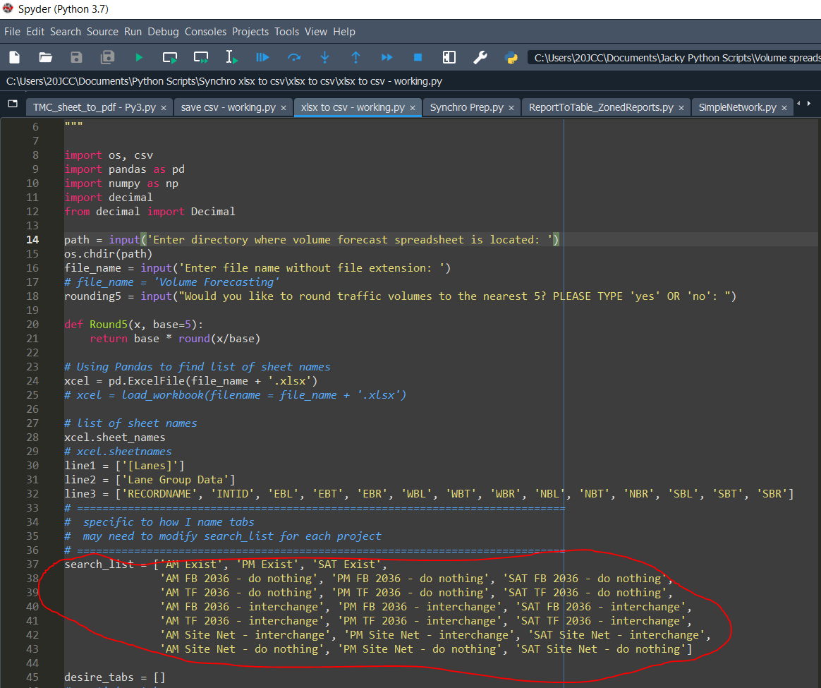

*\*\* currently matches for the sample volume spreadsheet provided*

1. Strings in search_list **MUST** match name of worksheets in volume forecasting spreadsheet
2. Worksheets **MUST** start with “AM” “PM” “SAT” “MID” to work. You will notice this in the sample search_list
   1. this is necessary so that the script can create csv files with name format required for Eric Stewart’s Python script for Inkscape figures.

# How it works (overview)

* will ask for directory of volume spreadsheet
* will ask for name of volume spreadsheet
* will ask to round 5 or not. **MUST** type ‘yes’ or ‘no’ otherwise script will not work

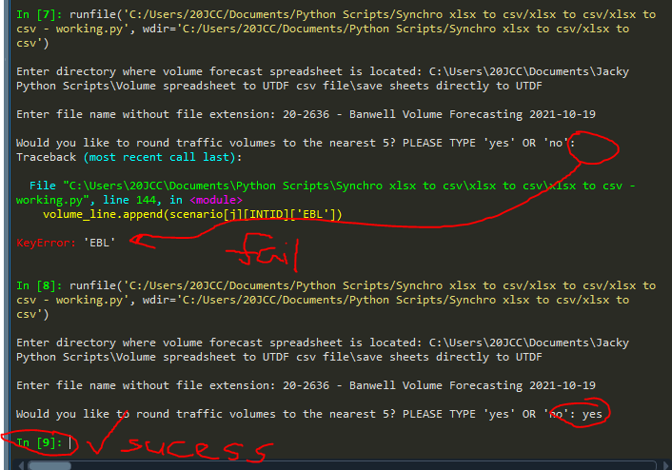

# Outputs

